DataAnalyticsWithTableau

Name : G.Jayachandra

Team Member – 3 Assignment - 1

*SupermarketSalesDataAnalysisReport–TableauVisualizations*

# BarChart:TotalSalesbyProductLine

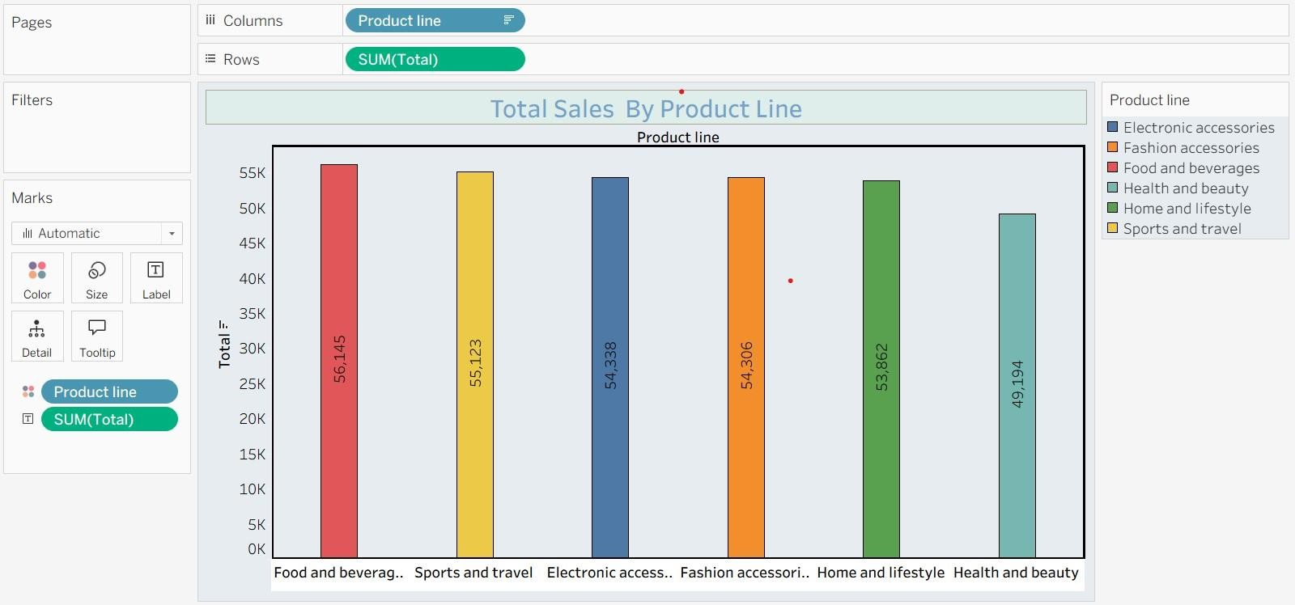

Thisbarchartcomparesthetotalsalesforeachproductline.

# PieChart:BranchWiseProfit

Thispiechartshowstheproportionoftotalsalesmadethroughdifferentpayment methods.

# StackedBarChart:Branch-wiseSalesbyGender

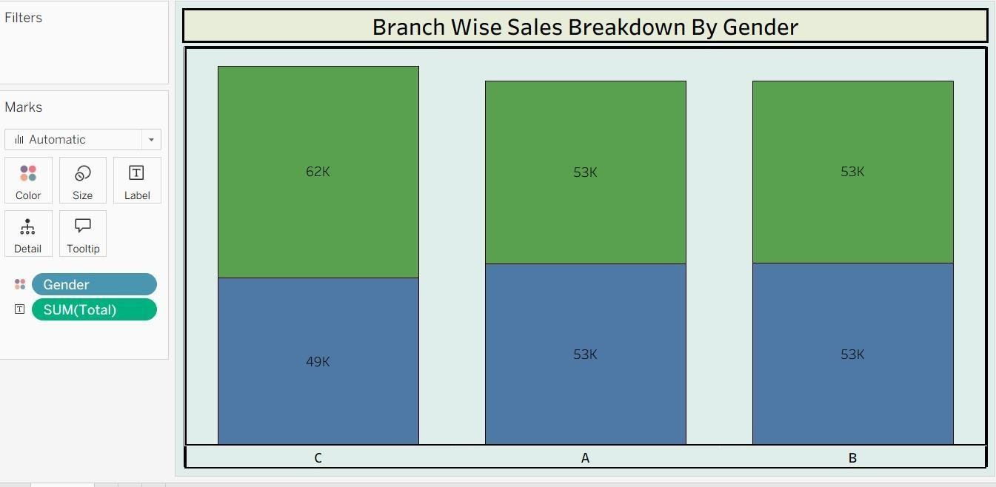

Eachbranch’ssalesarebrokendownbygendertoanalysecustomercontribution.

# LineChart:Month-wise Sales

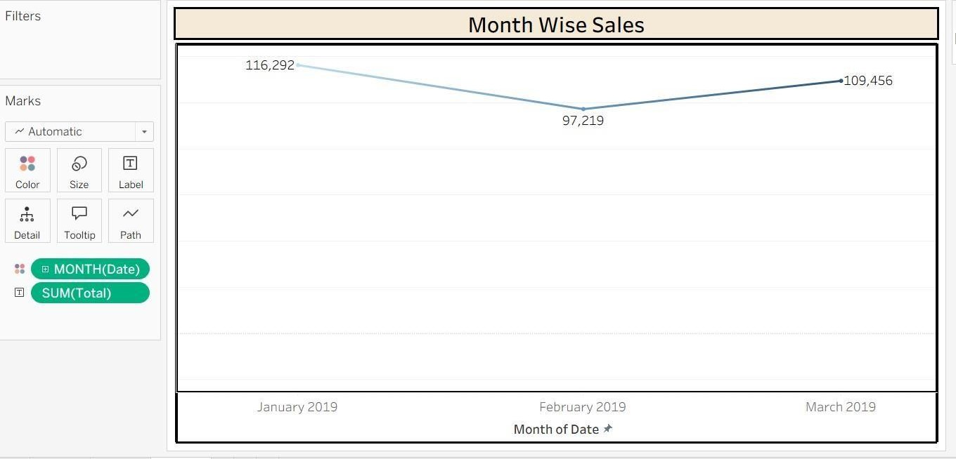

ThislinechartshowshowtotalsaleshavevariedfromJanuaryto March.

# BubbleChart:ProductLine-wiseSales

Eachbubblerepresentsaproductline,itssizeindicatestotalsalesvolume.